Sling Model Exporters

**What & Why?**

These are same old sling models equipped with extra set of few more annotations which enhance us to render the data we create with sling models in different renditions – mostly JSON to cater to external REST API’s

**How to convert an Existing Model as Exporter**

Right below the @Model annotation,

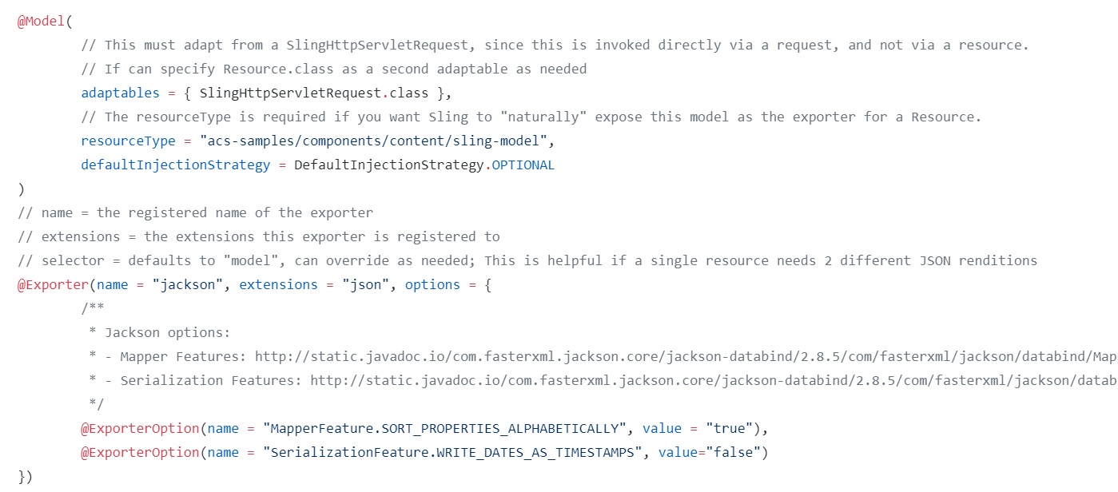

To invoke the sling model exporter - *${crx.host}:${crx.port}${path-to-resource}.${selector}.tidy.${extension}* –

**Creating a custom Exporter**

**Useful Links**

<https://github.com/FasterXML/jackson-annotations/wiki/Jackson-Annotations>

<https://docs.adobe.com/content/help/en/experience-manager-learn/foundation/development/develop-sling-model-exporter.html>

<http://www.sgaemsolutions.com/search?q=exporter>